Motivation Letter

This fellowship program is intended to contribute to the promotion of Sustainable Development Goals (SDGs). Then, this program provides financial support to doctoral students who have the strong motivation of the SDGs realization. Furthermore, this program is also aiming to develop human resources who will act in the “Post-SDGs” society after 2030.
All applicants shall describe a motivation letter according to the following topics (①～④).
- Select the SDGs item(s) that your research may contribute to.
- Describe the details of the impacts and contributions of your research proposing this application to the realization of SDGs.
- Describe your previous or future activities and effort related to achieving SDGs (e.g. completed a class or special education program, participation in symposiums or seminars, group activities inside or outside the university)
- Describe your plan and further activities contributing to achieving SDGs in your career path after completion of your research proposing this application and with the perspective of after 2030.

①Please check the SDGs item(s) that your research may contribute to (multiple selections allowed)

☐ ☐ ☐ ☐ ☐ ☐

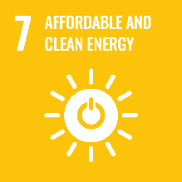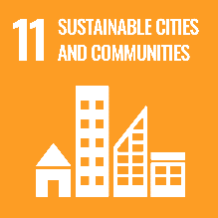
☐ ☐ ☐ ☐ ☐ ☐

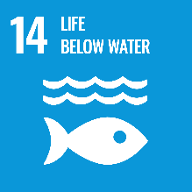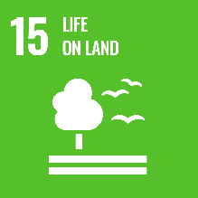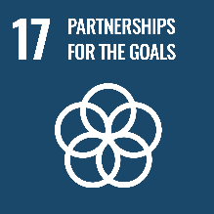
☐ ☐ ☐ ☐ ☐
Please describe ② to ④. 【Approximately 1 page】

